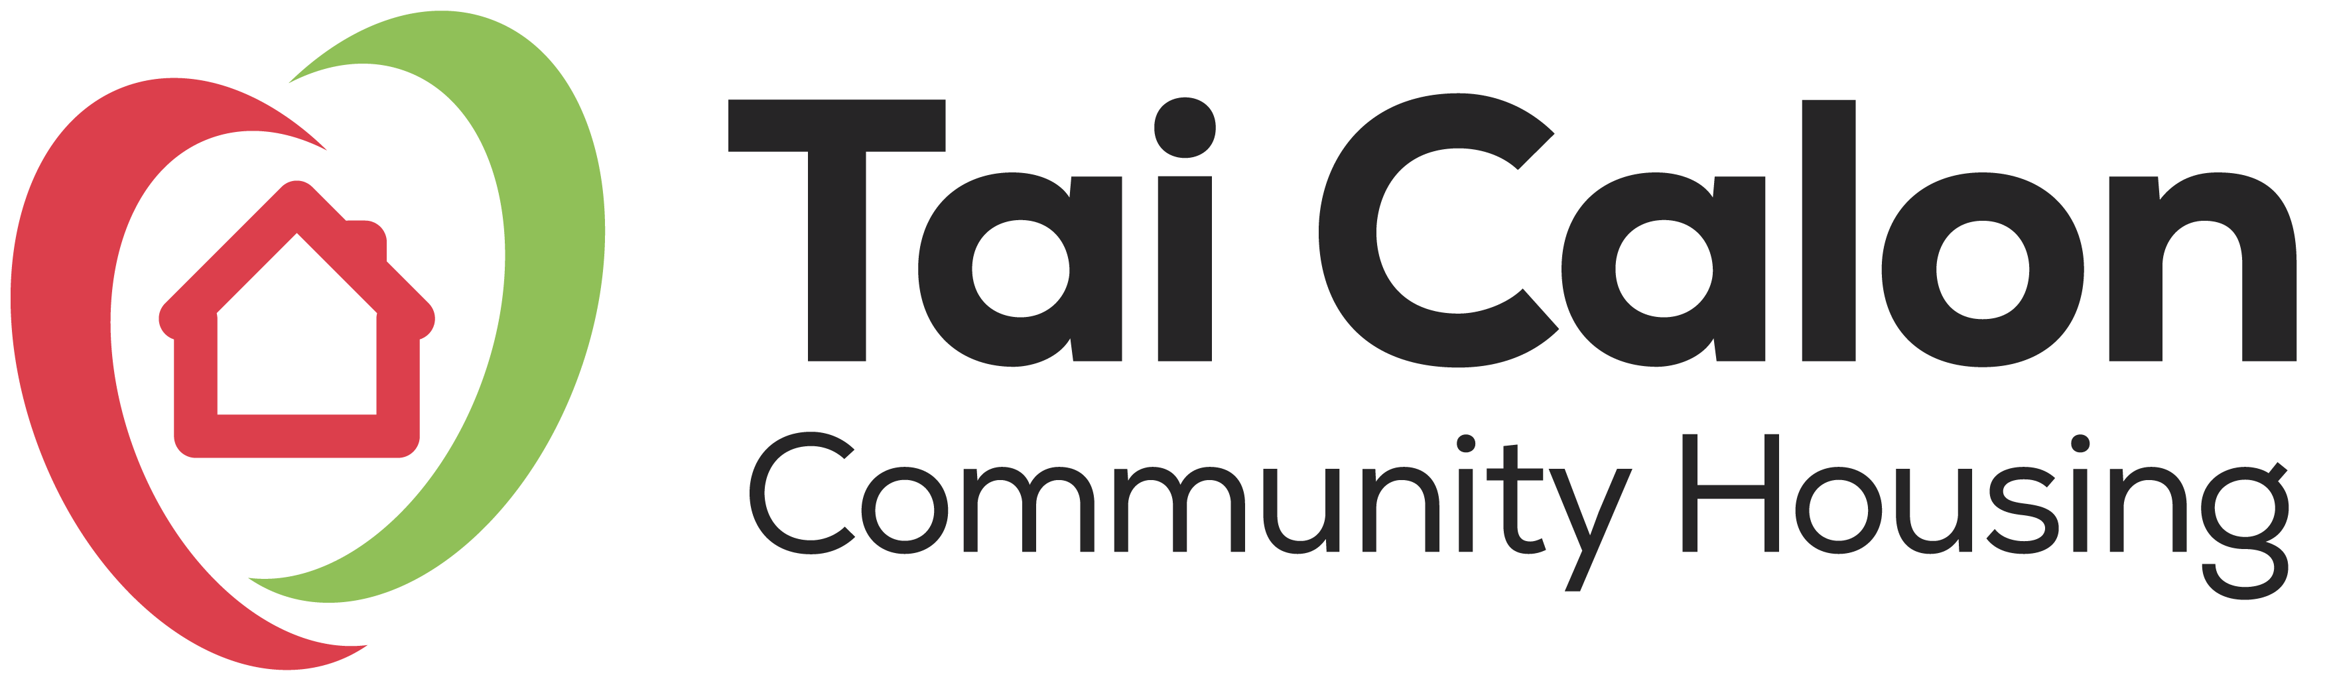

Policy Name: Healthy Homes Policy (Damp, mould and condensation)
We know that damp, mould, and condensation can harm people and damage homes. We promise to keep homes safe, in good condition and everything we can to keep them warm so everyone can live healthier and happier lives.

Our Policy Promise
What we’ll do | What this means for you
Provide all our policies in different formats and languages. | You can tell us what format or language you need.
We make our policies easy to follow by splitting them into two parts; what we’ll do and what this means for you. | This helps you understand the service we offer.
We will follow our Vulnerable Customer Policy for helping customers who need extra care. | You will get the help you need to report repairs and take care of your home.

Policy Objectives
We want to make sure all our homes are repaired, maintained, or made better so everyone has a safe, warm, and nice place to live. We promise to do everything we can to stop damp, mould, and condensation.
Helping You
What we’ll do | What this means for you
We will give you easy-to-understand advice on how to deal with damp, mould, and condensation. | You can find helpful tips on our website and in our leaflets, including how to heat and ventilate your home, keep moisture low and treat small areas of mould before it gets worse.
We will understand your needs and work with you to make sure your home is safe and warm. | You will get a service that gives you the best help just for you.
We will team up with others to give you extra help if needed. | You will get support from other teams, like help with paying energy bills.
We can give you sensors to check moisture levels in your home. | This helps us see if there are any problems starting. You can also use a mobile app to keep track of this.
We will tell you when planned energy improvement works will be carried out to your home. | This will help you keep your home warm and well ventilated reducing the chance of damp, mould and condensation.
We will carry out a stock condition survey of your home every five years. | This is a proactive inspection to find out what works will be needed to your home in the future and when. We will check for any damp, condensation and mould as part of the stock condition survey

Getting Help
What we’ll do | What this means for you
We will make it easy for you to contact us. | You can call us, email us, go online, visit us in person, or reach out on social media. We will make sure it's easy for you.

Fixing Problems in your Home
What we’ll do | What this means for you
We will check any reports of damp, mould, or condensation within 12 working days. | You will have our team check your home. They will find out what is causing the problem, see how bad it is, and decide what needs to be done
In difficult cases, we will ask expert surveyors to look at the problem and give advice. | They will check everything carefully and tell us what to do to help you the best.
We will fix things based on how urgent and risky they are. We will look at how many problems there are, where they are, if there is mould, and who lives in the house (like their age and health). | This means we will fix things quickly for you, especially if the problem is serious or affects your health.
Your Home Matters to Us
What we’ll do | What this means for you
We'll check in with you at 3, 6, 12, and 24 months after the repair to make sure everything is okay. | After we fix things, we'll make sure the damp, mould, and condensation are gone.
We want to keep your home safe from damp, mould, and condensation. To do this, we'll collect new information to find problems before they happen. | We can make better choices, work faster, and stop problems before they start.
We will fix or improve things to stop damp, condensation or mould before it happens or to make sure it is less chance of it happening again | This means that we will fix or improve things before they become a problem

Other related legislation
- Rented Homes (Wales) Act 2016
- The Welsh Development Quality Requirements (WDQR) 2021
- Fitness for Human Habitation Standard (FFHH)
- The Welsh Housing Quality Standard (WHQS) 2023
- Lifetime Home Standard
- The Health & Safety at Work Act 1974
- The General Data Protection Regulation 2018
- The Equalities Act 2010
- The Human Rights Act 1998
- Housing Act 1996

Other related policies and procedures
- Responsive Repairs Policy
- Maintenance Repairs Policy
- Gaining Access for Repairs Procedure
- Customer Care Policy
- Vulnerable Customer Policy
- Chargeable Repairs Policy
- Concerns & Complaints Policy
- Compensation Policy
- Code of Conduct
Equality & Diversity
To promote fairness, inclusivity, and adherence to equality principles, we have conducted an Equality Impact Assessment.

Review
We will review this policy either when necessary or every 3 years. During any review, we will consider customer feedback and any changes in regulatory guidance and best practices.
Chief Executive/Director Approval:
Board Approval Date:
Date of next review:

Visit our offices or write to us at:
Tai Calon Community Housing, Solis One,
Rising Sun Industrial Estate, Blaina, Blaenau
Gwent NP13 3JW

Email us: talktous@taicalon.org
Phone: 0300 303 1717
Find us on the web at: www.taicalon.org.

